Name – Harshad Khedekar
Email – harshadkhedekar123@gmail.com

- How and when to use the AutoSum command in excel?

- Whenever you need to sum a single range of cells, whether a column, row or several adjacent columns or rows, you can have Excel AutoSum to automatically make an appropriate SUM formula for you.
- To use AutoSum in Excel, just follow these 3 easy steps:

- Select a cell next to the numbers you want to sum:
To sum a column, select the cell immediately below the last value in the column.
To sum a row, select the cell to the right of the last number in the row.
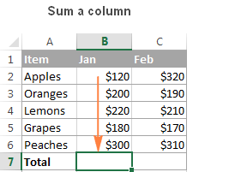
- Click the AutoSum button on either the Home or Formulas tab.
A Sum formula appears in the selected cell, and a range of cells you're adding gets highlighted (B2:B6 in this example):
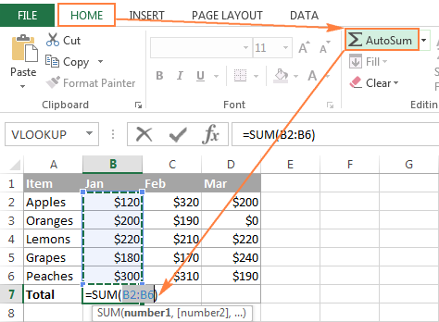
In most cases, Excel selects the correct range to total. In a rare case when a wrong range is selected, you can correct it manually by typing the desired range in the formula or by dragging the cursor through the cells you want to sum.
- Press the Enter key to complete the formula.
Now, you can see the calculated total in the cell, and the SUM formula in the formula bar:
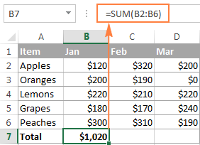
- Excel's AutoSum button to insert other functions, such as:
- AVERAGE - to return the average (arithmetic mean) of numbers.
- COUNT - to count cells with numbers.
- MAX - to get the largest value.
- MIN - to get the smallest value.

2. What is the shortcut key to perform AutoSum?
The Autosum Excel shortcut is type two keys:
ALT =
- Step 1: place the cursor below the column of numbers you want to sum (or to the left of the row of numbers you want to sum).
- Step 2: hold down the Alt key and then press the equals = sign while still holding Alt.
- Step 3: press Enter.

3. How do you get rid of Formula that omits adjacent cells?
To turn off the notification "Formula Omits Adjacent Cells" you're getting, kindly follow the steps below:
- Open Excel and then click on File.
- Go to Options and then select Formulas.
- Look for Error checking rules and uncheck Formulas which omit cells in a region.
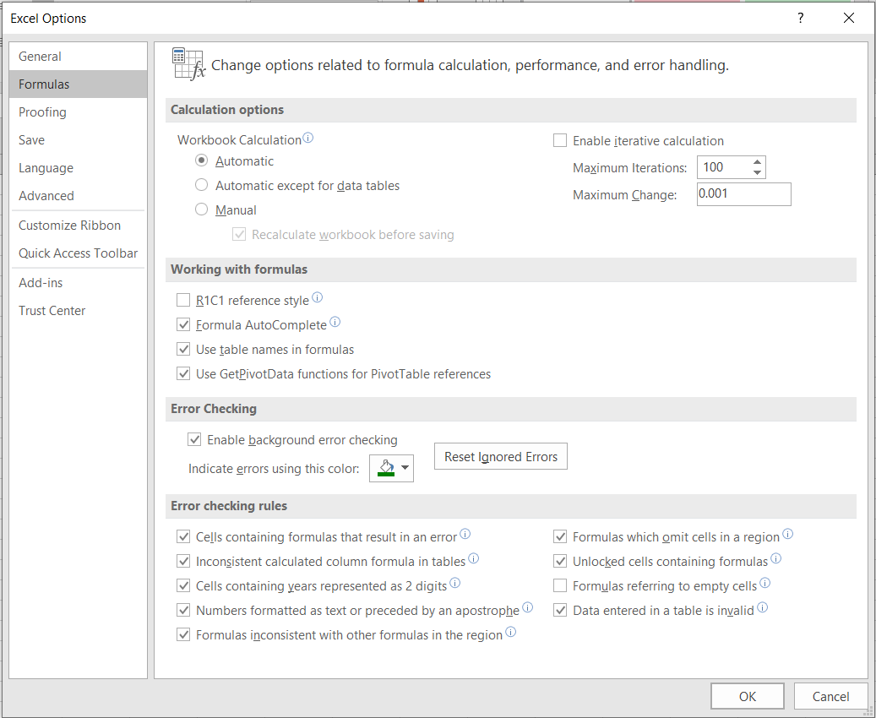
- Click OK.
4. How do you select non-adjacent cells in Excel 2016?
- To select non-adjacent cells and cell ranges, hold Ctrl and select the cells.
- To select non-adjacent rows or columns, hold Ctrl and select the row or column numbers.
- To select a range, select a cell, then with the left mouse button pressed, drag over the other cells.
Or use the Shift + arrow keys to select the range.

5. What happens if you choose a column, hold down the Alt key and press the letters ocw in quick succession?
- The column width dialogue box opens allowing you to set the exact width of the column.
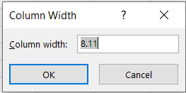
6. If you right-click on a row reference number and click on Insert, where will the row be added?
- ‘Below the Row’ New Row will be added

